**FIT – Madrid & Barcelona**

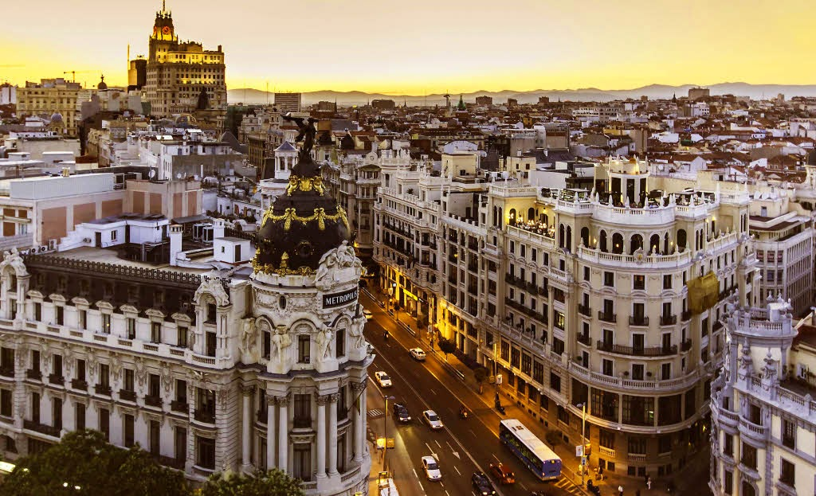 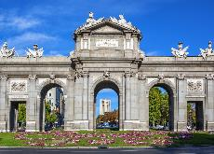 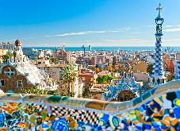 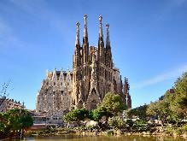

**day 1 Madrid**

arrival at **Madrid** airport.

**private transfer** from airport to hotel.

**Madrid** **sightseeing** based on a hop on- hop off bus.

*one of the easiest and most comfortable ways of discovering Madrid.* ***highlights of the tour****: Gran Vía, Plaza de España, university, Moncloa, Habsburg old quarter, Calle Mayor, Puerta del Sol, Puerta de Alcalá, Paseo de la Castellana and the* ***Real Madrid Stadium, Santiago Bernabéu*** *(tour of the stadium available).*

overnight at hotel in Madrid.

**day 2 Madrid**

breakfast at the hotel.

half day **Toledo excursion** on regular basis.

*Toledo is one of the Spanish cities with the greatest wealth of monuments. known as the* ***“city of the three cultures”****, because Christians, Arabs and Jews lived together there for centuries, behind its walls Toledo preserves an artistic and cultural legacy in the form of* ***churches****,* ***palaces****,* ***fortresses****,* ***mosques*** *and* ***synagogues****. this great diversity of artistic styles makes the old quarter of the capital of La Mancha a real open-air museum, which has led to it being declared a world heritage site.*

overnight at hotel in Madrid.

**day 3 Madrid - Barcelona**

breakfast at the hotel and check out.

**private transfer** to Madrid train station. train from Madrid to Barcelona.

**private transfer** from train station in Barcelona to the hotel.

**Barcelona** **sightseeing** based on a hop on-hop off bus.

*the tour will highlight all the things to do in the city so that you can hop on and off at your convenience at more than 44 stops. the key sights and world famous attractions of this fantastic city are included on the tour including* ***the gothic quarter*** *which is the centre of the old city of Barcelona. a great number of buildings are world heritage sites. especially remarkable is the work of architect* ***Antoni Gaudi****, which can be seen throughout the city;*  ***the Sagrada Familia cathedral, Casa Batlló, Casa Mila and Park Güell.***

overnight at hotel in Barcelona.

**day 4 Barcelona**

breakfast at the hotel.

half day excursion to **Montserrat**.

*Montserrat, the holy mountain, with weird shapes and rounded peaks that jut into the sky offering impressive views. an almost 1000 year old monastery hosts the oldest boys' choir in Europe. located 1 hour driving from Barcelona.*

overnight at hotel in Barcelona.

**day 5 Barcelona**

breakfast at the hotel and check out.

**leisure time** to enjoy the city before departure. you could spend the morning shopping along the famous **Las Ramblas** or enjoying the beach and the **Olympic Port**.

**private transfer** to Barcelona airport.

**end of services**

**prices**

|  |  |  |  |
| --- | --- | --- | --- |
| **price per person & package** | **Nov - Mar** | **Apr - Oct** | **Jul - Aug** |
| **standard class** | **430 €** | **485 €** | **470 €** |
| child standard price  (up to 12 yrs) | **217 €** | **225 €** | **215 €** |
| single supplement | **140 €** | **170 €** | **170 €** |
| **first class** | **475 €** | **530 €** | **500 €** |
| child first price  (up to 11 yrs) | **175 €** | **190 €** | **190 €** |
| single supplement | **178 €** | **225 €** | **201 €** |
| **superior class** | **555 €** | **681 €** | **595 €** |
| child superior price  (up to 11 yrs) | **82 €** | **82 €** | **82 €** |
| single supplement | **242 €** | **345 €** | **275 €** |

* prices per person based on double room & bb basis. taxes included. prices valid for minimum 2 traveling pax. prices for children sharing room with 2 adults.

* prices subject to availability and possible fluctuations in any of the requested services at the time of final booking

**validity**: **until October 2020.**

inclusions:

|  |  |  |  |  |
| --- | --- | --- | --- | --- |
| **city & nights** | **transfers** | **Sightseeing on SIC basis** | **meals** | **24h. phone**  **assistance** |
| **2n Madrid** | private  apt-htl-station | hop on hop off bus  half day Toledo excursion | breakfast |
| **2n Barcelona** | private  station-htl-apt | hop on hop off bus  half day Montserrat excursion |

price does not include:

* regional tourist tax.
* tips and guests´ extras.
* any other service not mentioned on the programme / itinerary described.
* train tickets, please find supplement below:
  + *AVE high speed train Madrid - Barcelona:   
    per person on tourist class:* ***from******107,70 €*** *(+ 4% handling fee)*
* **transportation to sightseeing meeting points is not included, we recommend the use of public transportation or taxi.**

**optional supplements**:

|  |  |  |
| --- | --- | --- |
| Bern  **football tickets**  **on request** (prices from 48 € to 1.176 €) | C:\Users\marketing2\AppData\Local\Microsoft\Windows\INetCache\Content.Word\madrid-entrada-santiago-bernabeu.jpg  **Real Madrid stadium tour**  adult: 25 € child (6-13):18 € | C:\Users\marketing2\Downloads\Camp02.jpg  **Barça – Camp Nou stadium tour**  adult: 26 € child (6-13): 21 €  *\*with time and date given* |
| C:\Users\marketing2\Downloads\tablao cordobes.jpg  **flamenco show & dinner in Barcelona**  adult, from: 50 € (vegetarian menu available) | C:\Users\marketing2\AppData\Local\Microsoft\Windows\INetCache\Content.Word\Flamenco-Madrid-400x300.jpg  **flamenco show & dinner in Madrid**  adult: 63 € (vegetarian menu and special children menu available) | C:\Users\marketing2\Downloads\banos-arabes-masaje-madrid-2.jpg  **arab baths & massage in Madrid**  from 59€ |
| C:\Users\marketing2\Downloads\tour-segovia-AA (1).jpg  **FD Ávila-Segovia from Madrid** on SIC basis  adult: 72 € child (6-13): 42 € |  |  |

* prices per person.

**itinerary & number of nights**

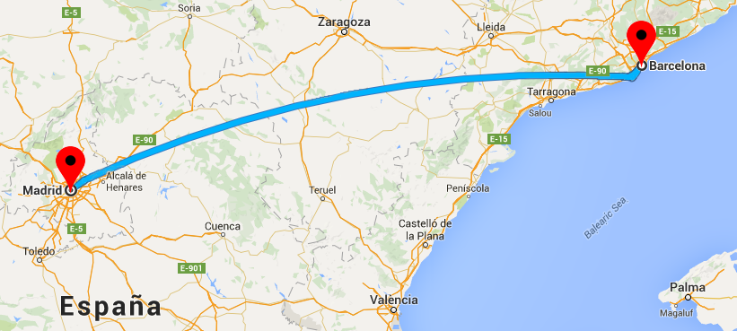

**2n**

**Madrid**

**2n**

**Barcelona**